**Photos of the BMW CCA Foundation Museum from May 18, 2021, taken by Michael Mitchell.**

This is how the building looked three days before the burial of the time capsule. GENESIS: BMW From the Beginning exhibit is scheduled to close on Saturday, May 22, 2021.



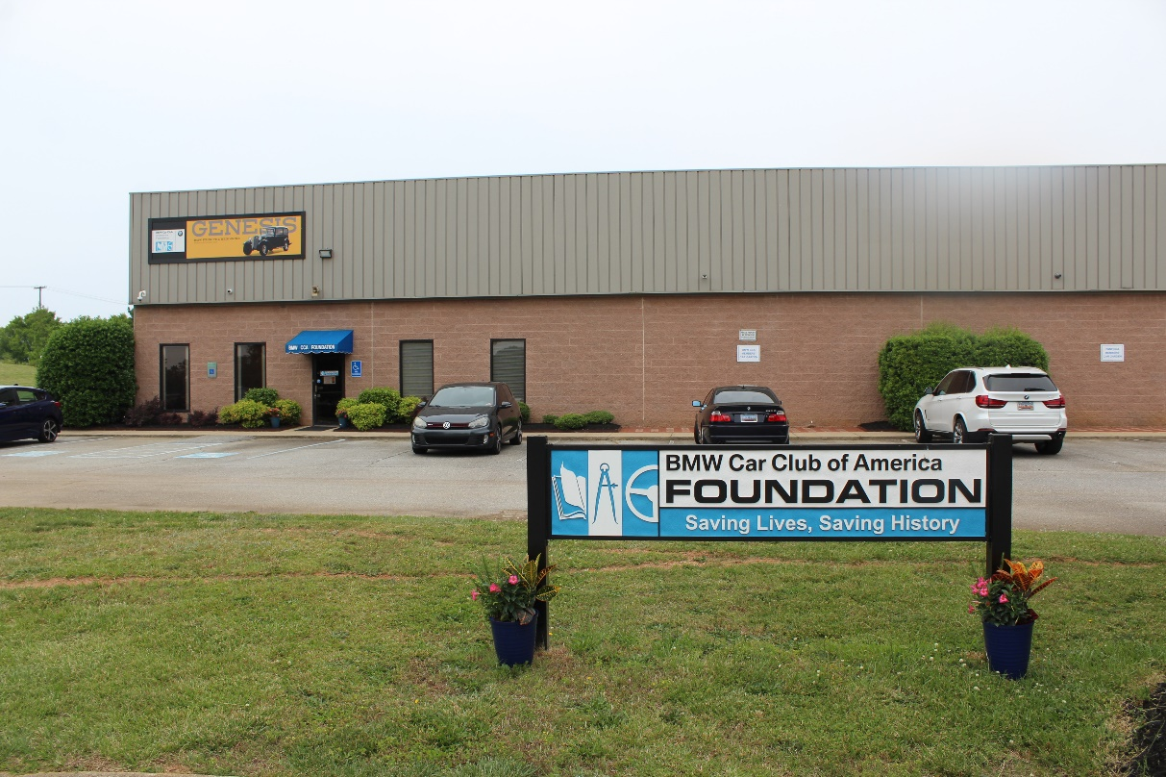

This is our reception desk for the admission sales and store sales.



This is our current gift store.



This is our seating area with our Museum Art Gallery showing the four exhibit posters. The seats are from the E36/7 Z3 M Roadsters

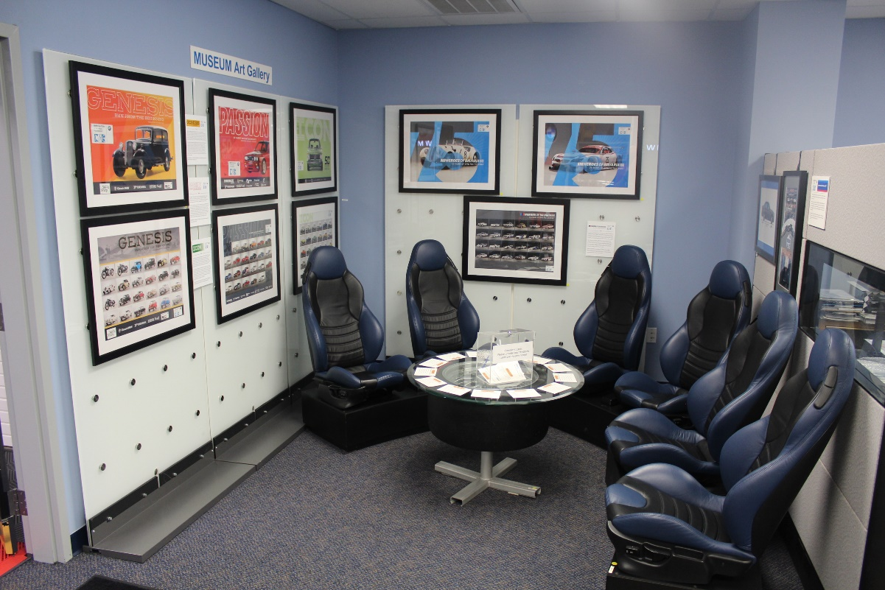

Photos from the GENESIS exhibit

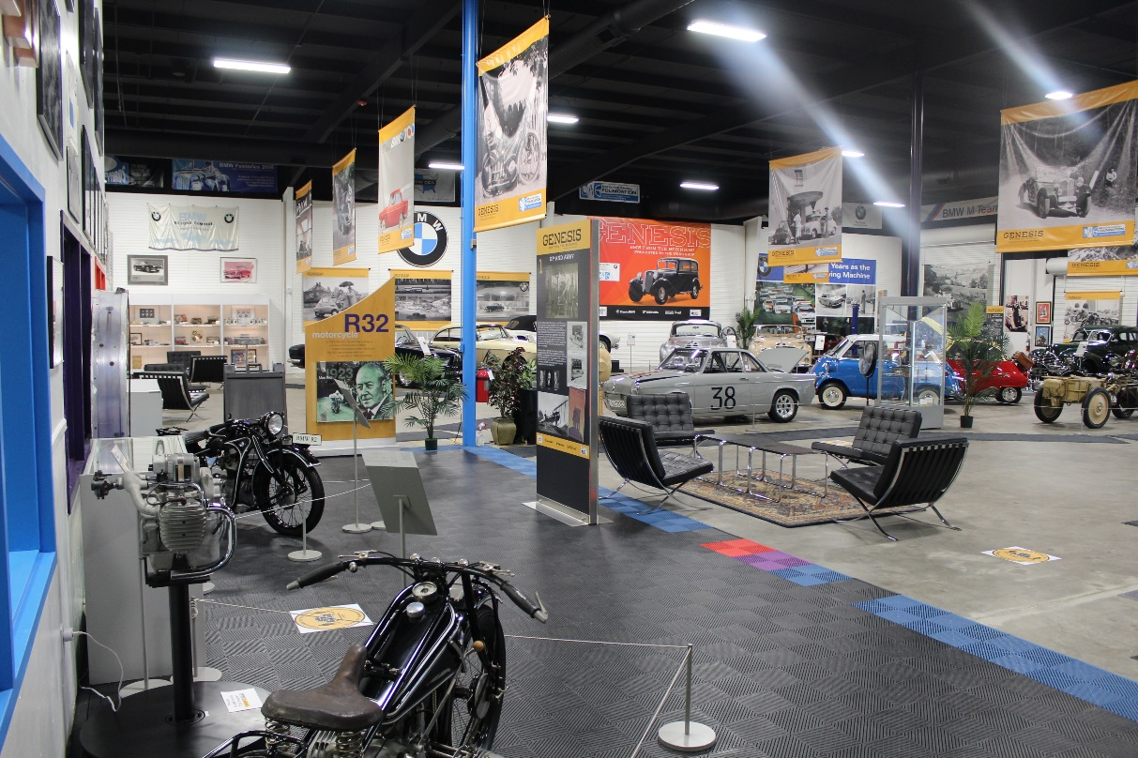

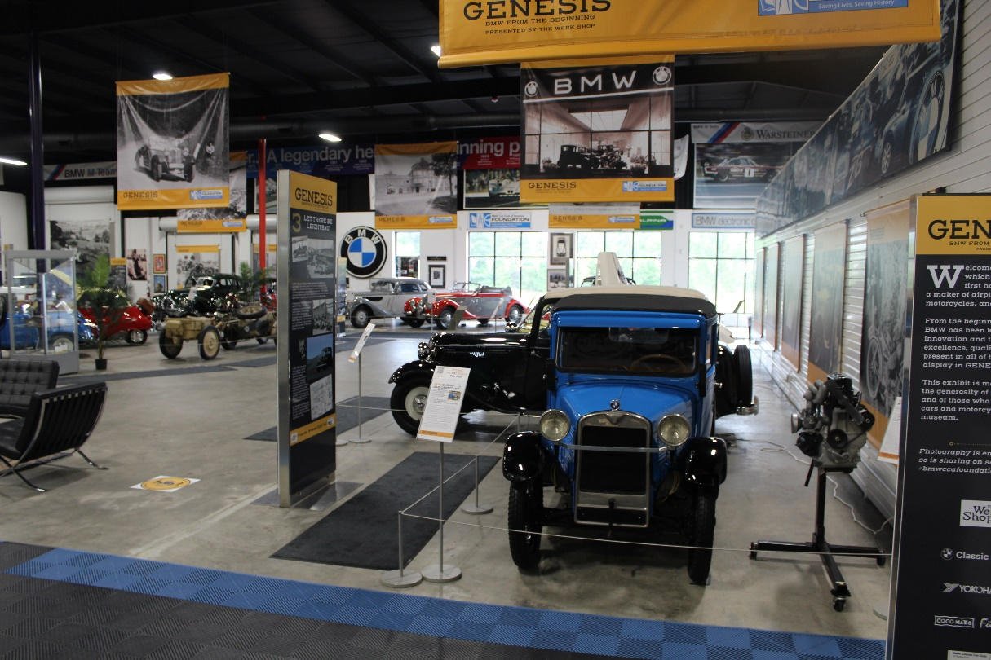

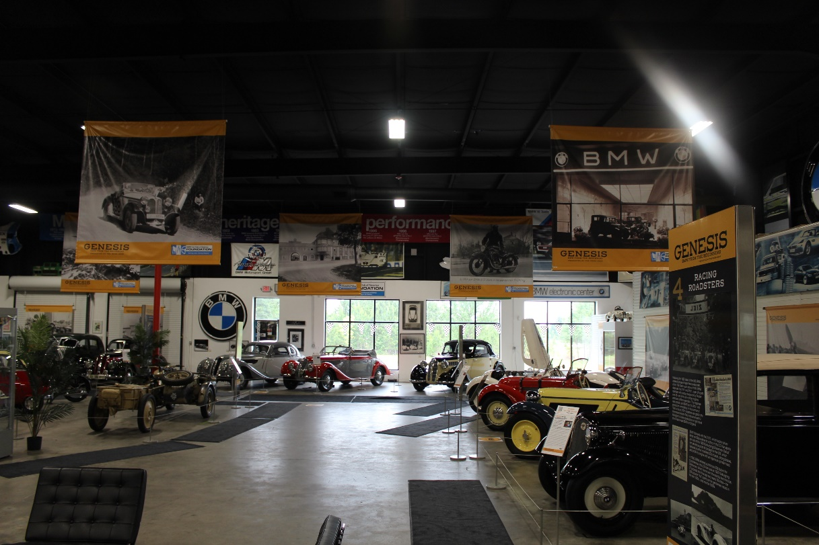

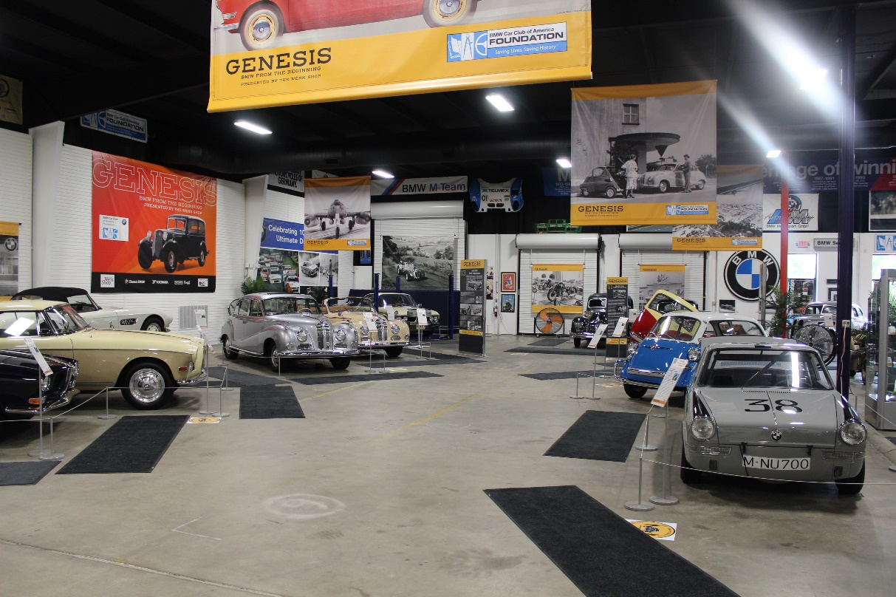

The new Founders’ Memorial Garden that will be launched on Friday, May 21

