Coffee watercolor art by Adrian Mitu for the GENESIS BMW From the Beginning exhibit

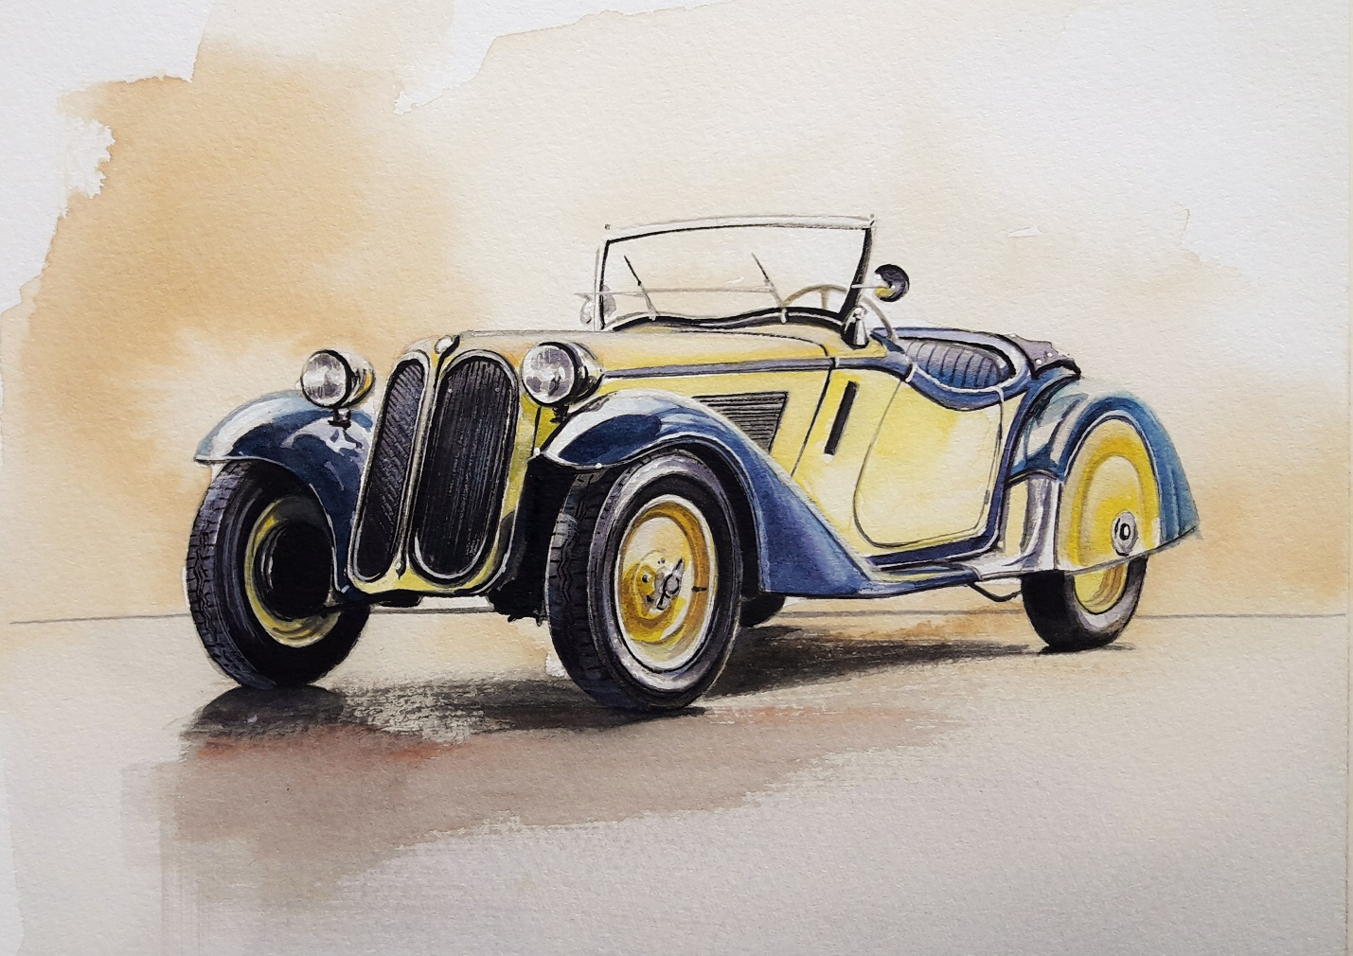

Dirk de Groen’s 1934 315/1 Roadster (above) and Rocky & Henry Grady’s 1954 EMW 327-2 (below)

